

RISK ASSESSMENT FOR: JS – Sports Hall

✓ | REASON FOR THE RISK ASSESSMENT
 | To identify potential hazards when using the Junior School Sports Hall and implement mitigating measures to reduce the risk of accidents/incidents.

This risk assessment is for: Junior School Sports Hall  Completed by: Chris Sweet  Position: Head of PE  Signed: Chris Sweet  Date: 10/09/2025  Next review due date: 10/09/2026 | 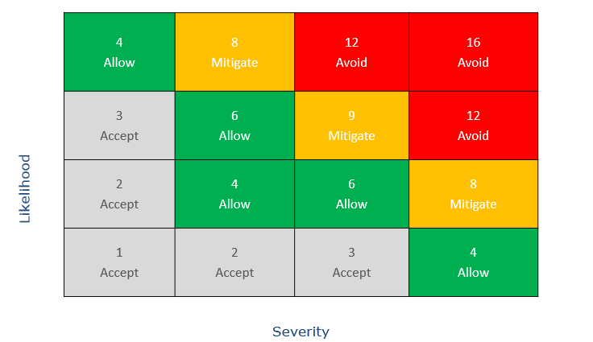 | Severity (S) 1-4  Likelihood (L) 1-4  Risk Rating (L x S)

Step 1: |  |  | Risk Ratings
Specify hazards or risks that may arise | Identify People Potentially at Risk | What Control Measures and Mitigation will be put in place to minimise any Risk | e.g 1 x 2 = 2 LOW RISK
Accidents due to a lack of pupil supervision | Pupils and potentially staff | Appropriate teacher pupil ratio as per current Government guidance on Gov.uk  Ensure there is a qualified first aider on site should an incident occur, first aid kit close to hand in PE office. | 1 x 3 = 3
Potential injury to individuals due to equipment failure | Pupils and staff | Equipment is annually tested by an approved external company. (Universal Services)  Daily visual checks to also be carried out by members of the sports department. Defective or damaged equipment to be taken out of use.  Pupils taught how to use equipment specifically and safely. | 1 x 4 = 4
Hair, clothing or jewellery entangled in equipment | Pupils/staff | Visual check of children. Children and Staff should wear appropriate clothing and shoes, remove jewellery and tie back long hair.  Keep the record of equipment inspection or statutory testing up to date. | 1 x 2 = 2
Children colliding with each other or equipment/obstacles | Pupils/staff | Designate a safe area. Draw attention to obstacles. Give safety talk if needed, highlighting any specific hazards or spaces to avoid. Control pace and numbers of people active in the space and intervene if children are ignoring instructions. | 1 x 2 = 2
Collisions with non-participants leading to personal injury | Pupils/staff | Ensure the area is free from other users. Teacher to remain vigilant to those who may enter the area. Halt session if required. | 1 x 2 = 2
Tripping and falling onto a hard surface | Pupils/staff | Make participants aware of dangers e.g. slipping, tripping. Remove any trip hazards, rubbish or equipment not being used. Any spills to be wiped up straight away. Ensure all lighting is operating correctly and report any defects to the Facilities team. | 1 x 2 = 2
Contact with foreign elements/objects on the playing surface | Pupils/staff | Inspect area prior to start of session, remove/ isolate any hazards. Report these on the Service Desk if further attention is required. | 1 x 2 = 2
Misuse or lack of control of equipment leading to purposeful or accidental striking of other people. | Pupils/staff | Reinforce safety messages and game rules. Work in controlled groups with specific individual tasks. Establish safe spacing between each group. Address any negative or potentially dangerous behaviour. | 1 x 2 = 2
Muscular injury though excessive stress/strain. Injury through incorrect execution of activity. | Pupils/staff | Follow aerobic and stretching warm up exercises. Use appropriate size/weight equipment. Follow PE curriculum guidelines and adhere to safe practice. Reinforce safety messages. | 1 x 3 = 3
Showing a negative physical response to exercise – overly heavy breathing, dizziness etc. | Pupils/staff | Observe physical responses. Teacher to Inform medical center if they consider that this is needed.  Know which students have existing medical problems which could be affected by sports activities or students that may require special attention. | 1 x 3 = 3
Falling object or projectiles eg balls | Pupils | Games / activities to be played in designated areas only under supervision of qualified staff. | 1 x 2 = 2
Twist/turn of joint eg ankle, knee, wrist | Pupils | Suitable warm ups and activities to be delivered. | 2 x 2 = 4
Exacerbate prior injury | Pupils | Ensure all students are fit to carry out planned activities, checking for underlying health conditions and make alternative arrangements for affected students if necessary. | 1 x 2 = 2
Lone Working | Staff, Students & Visitors | Members of staff should have completed the Lone Working training on Every.  Staff undertaking lone working to develop an appropriate safety protocol with their line manager. | 3 x 3 = 9

Step 2: Action Needed/Comment | Responsible Person | Date Completed

Signed: Chris Sweet Title: Head of PE Date: 10/09/2025

