

RISK ASSESSMENT FOR: Astro

✓ | REASON FOR THE RISK ASSESSMENT
 | To mitigate any risks associated with the activities that take place on this surface.

This risk assessment is for:  The students, staff and visitors using this facility.  Completed by: Linden Lockhart  Position: Director of Sport  Signed: Linden Lockhart  Date: 2/10/2025  Next review due date: 01/10/2026 | 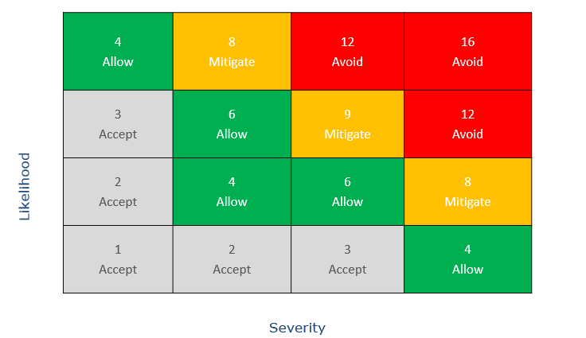 | Severity (S) 1-4  Likelihood (L) 1-4  Risk Rating (S x L)

Step 1: |  |  | Risk Ratings
Specify hazards or risks that may arise | Identify People Potentially at Risk | What Control Measures and Mitigation will be put in place to minimise any Risk | e.g 1 x 2 = 2 LOW RISK
Slips, Trips & Falls | Staff, Students & Visitors | - Close supervision at all times  - Member of staff to visually inspect the area and log any issues  - Cones used to mark off any potential hazards  - Astro to be assessed prior to an activity. If the pitch is frozen or standing water is present, activity will be cancelled.  - Appropriate footwear to be worn by all students and staff.  - Signs to inform spectators that they are at risk when watching sport on the astro. They must be aware that balls can be hit/ kicked over the fence, potentially causing injury or damage.  - In the case of extreme weather conditions, the staff will use their professional experience as to whether it is safe to use.  - In the case of use after break time, a visual check is carried out by staff prior to teaching and any unwanted items will be removed before use.  - At the end of a session, the areas will be tidied and clear of hazards by a member of staff. | 2 x 4 = 8
Manual Handling | Staff, students & visitors | - All staff to have completed manual handling training on Every. | 4 x 1 = 4
Lone Working | Staff, students | - All staff to have completed the lone working training on Every. | 4 x 1 = 4
Equipment Failure | Staff, students & Visitors | - All kit manually checked BEFORE USE - especially hockey goalkeeping equipment. Any defective equipment will be taken out of use and the Director of Sport advised.  - Annual inspection to be carried out by Universal Services.  - All kit at the astro to be locked up and inspected every week.  - Year 7 & 8 students will play fixtures diagonally at this point, they will be required to shoot at goals with a low fence behind them. | 2 x 2 = 4
Unauthorised Usage | Staff, students & Visitors | - All users of the facilities must be a member of the school during term time. Anyone who is not would be asked to leave  - Staff must have mobile phones for emergencies  - Due to public access the pitches need thorough inspection for damage/foreign objects before students use them. | 2 x 4 = 8
Inappropriate clothing or PPE | Staff, students & Visitors | - Appropriate sports specific shoes should be worn at all times. Dress shoes, flip-flops, sandals, open-toe and deck shoes are not permitted.  - Shin pads, mouthguards and correct kit for sports played must be worn at all times – if a student has no mouthguard they are permitted to join in with non contested skills. | 1 x 2 = 2
Surface Area | Staff, students & Visitors | - Where the carpet meets the tarmac path, there is a difference in levels, which can cause the ball to ricochet at head height in extreme circumstances. Care and awareness is advised. | 2 x 4 = 8
General Sports Activities | Staff, students & Visitors | - No shooting drills to be conducted diagonally across the pitch. All shooting at goal must be towards a goal with a high fence behind it.  - Only year 7 & 8 are allowed to play diagonally across the pitch, but in training sessions they may only push the ball at goal, not hit.  - Staff to prevent any students from hitting the ball at any low fence on the astro.  - Signage to be put in place to warn spectators of hockey balls being hit over the fence. | 2 x 2 = 4

Step 2: Action Needed/Comment | Responsible Person | Completed Date
Termly check on Astro fence | LL or AB | Once a term
Discussion with Darren Scott on supervision of evening usage | LL | ASAP
Review of signage around the astro | L Mayatt | September 24
Follow up with staff outstanding on manual handling training | LL

Agreed by: Lara Wilkinson

Signed: Linden Lockhart Title: Director of Sport Date: 2/10/2025

